**Tower & Slingshot**

1. Overview

# Genre

* Slingshot game
* Tower defense game

# Description

* In the future, the world suffered from the zombie crisis, and civilization and fairness of society no longer exist. Humans have the ability to control the zombies but all safe areas are controlled by the financial magnate. They also carried out a game for the upper class to have fun.
* The main character is a wronged high-tech talent, and he is also a candidate of the game. He needs equipment in this game through the continuous killing waves of zombies, so that he can survive.
* *The story will not appear in the game.

# Core Gameplay

* Defend against enemies and protect your base from them:
* Use gold to launch balls with slingshot to build and upgrade towers to kill enemies and gain gold.
* Also launch balls to slow down and harm the enemies to cooperate with defense tower.

# Targeted Platform

* VR

# Target Audience & Player Experience

* 16~35 years old, Male, Tower defense game lovers and shoot game lovers.
* Feel the strategy of reasonably matching defense towers.
* The sense of accomplishment of cooperating with your defense towers to resist zombies.

# Art Style

* Cartoon style

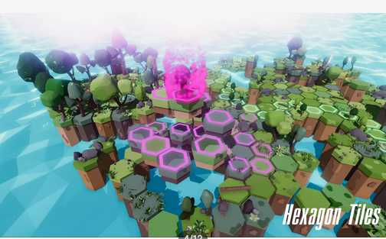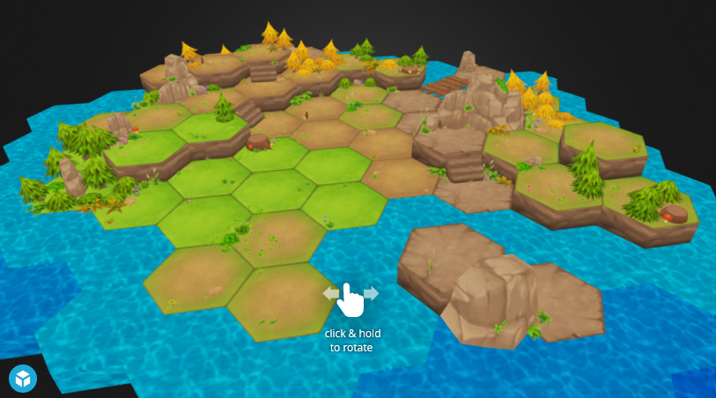

# References (Brief)

* Goblin Fighter
* The Lab

# Production Details

## Production Team

* Designer: Jerry, Cloud
* Art Designer: Yuki, Deidara
* Programmer: April, Matt
* PM: Oprah

## Software

* Game Engine: Unity
* Art & UI: PS
* Script: Visual Studio

1. Core Pillar

# Defensive tower

* Players need to purposefully select defense towers and choose suitable places to build them.

# Launch with slingshot

* Launch 4 kinds of balls with a big fixed slingshot:
* Building balls to build towers, also used to upgrade towers by launch them on existing towers of the same type.
* Selling balls to sell towers.
* Harm balls to harm the enemies.
* Ice balls to slow down the enemies.
* If failed to target, lose gold of 10% cost of the ball.

# Coordinate

* Player cooperates with defense towers:
* When enemies enter areas with dense firepower coverage, launch ice balls to slow them down to help towers deal more damage.
* When you have no gold, launch free harm balls to deal some damage to enemies.

1. 3Cs

# Character

## Background:

* The player is a player in a virtual arena.

## Personality:

* Determined, Optimistic, Firm

## Ability:

* Build defense towers, upgrade defense towers, shoot.

# Camera

* VR first-person perspective from a high location looking down

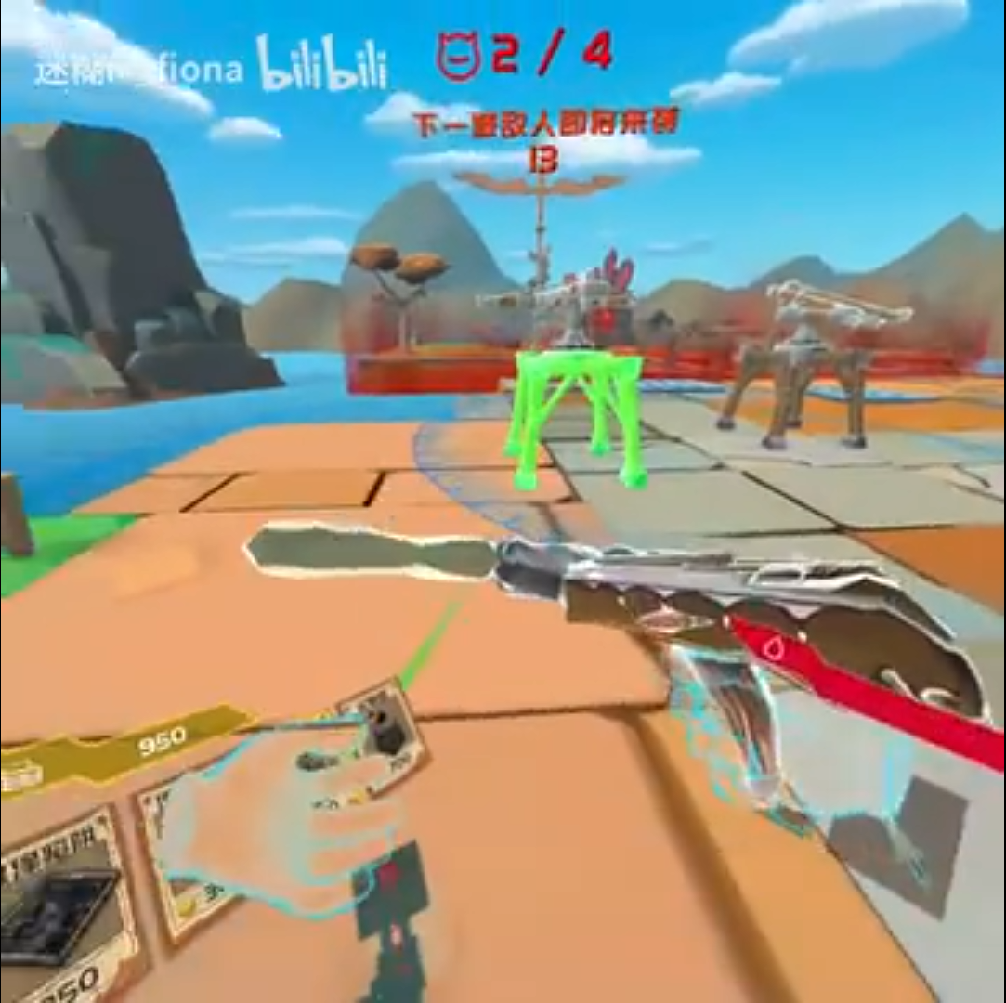

# Control

## Build

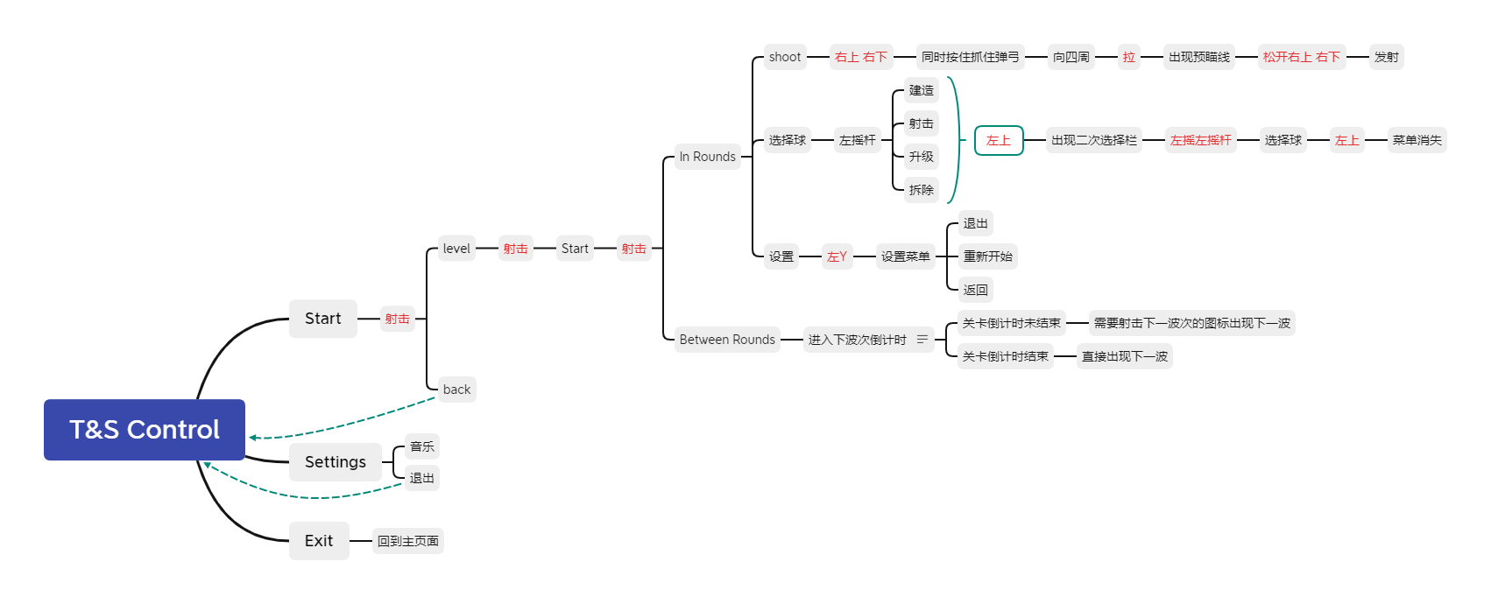

1. Gameplay

# Core Game mechanics

## Throw

* During combat, you can increase fault tolerance through damage and deceleration caused by Throw.

## Throw to Build

* If players need to build and upgrade buildings, they need to achieve this by throwing.

## Throw to Upgrade Tower

* Players can choose to upgrade tower defense. Each upgrade will increase the attributes of the tower. When the tower is upgraded, the color will change (primary color - silver - gold).

# Map

* There are three different blocks in the map, which are divided into enemy paths, tower defense blocks, and useless blocks

1. Key Features

# Diverse options to defend against the enemy

* Tower defense is the best way to kill enemies, but players' slingshot can slow down and cause damage to the enemy. Players need to cooperate with towers to kill enemies to protect the base

# A wide range of defense towers

* In the game, there are many defense towers for players to choose from. Players can choose different defense towers and take advantage of the features of defense towers to deal more damage.

# High degree of freedom of action

* Players can call up menus at any time to choose different balls to deal with different enemies

# Throw to build, upgrade and sell

* Building, upgrading and selling defense towers is done by throwing balls. The system will not give players full of the parabola, but only half of it will be displayed.

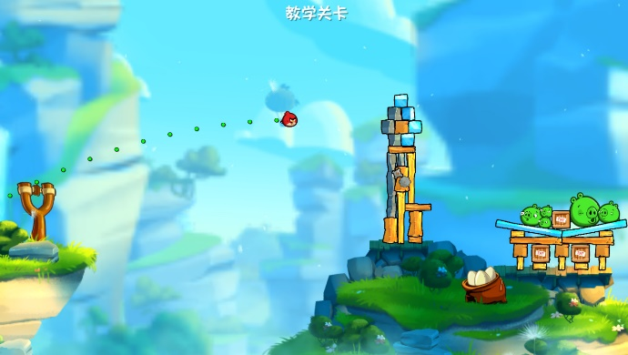

1. Game Details

# Enemy

* Name:
* Movement speed
* HP
* Gold
* Unique feature

# Weapon

* Deceleration ratio
* Hurt

# Tower

* Name
* Firing rate
* Price
* Hurt
* Scope
* 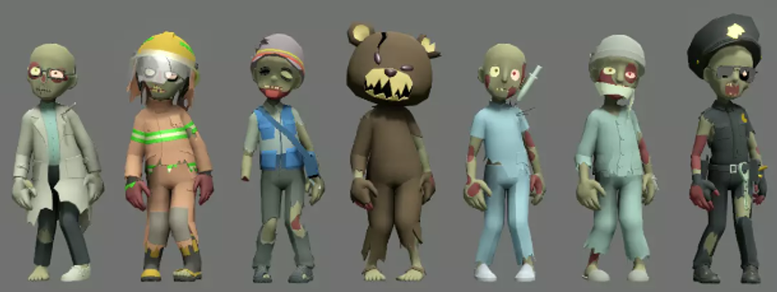Characteristics
* Shooting method

1. Art Style

* Cartoon style

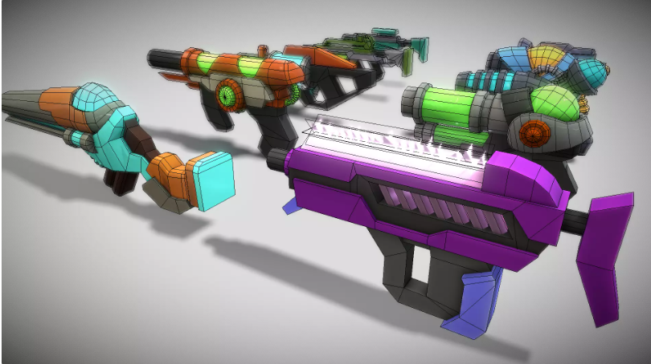

1. Reference

* The Lab:
* Camera, art style, core mechanics

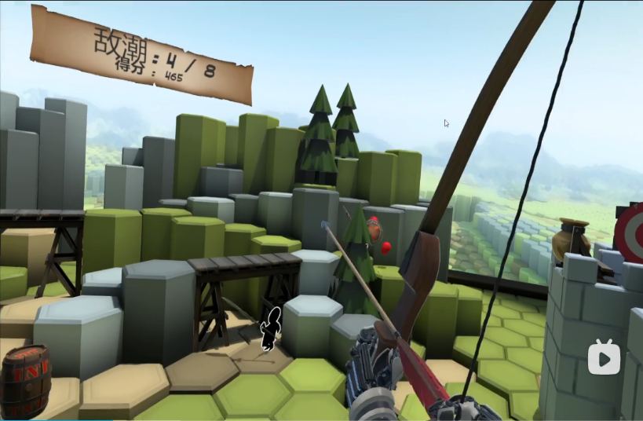

* Goblin Fighter:
* Core gameplay, camera.

